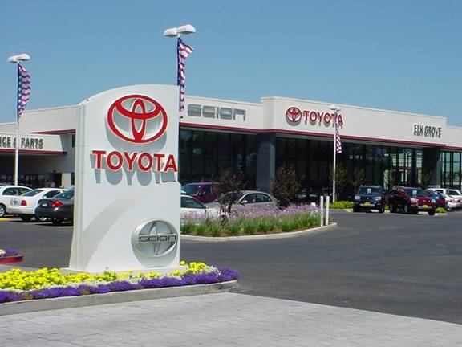
TOYOTA AUTOMOBILES COMPANY PROMOTION 2012.
ADDRESS: 22 GARDEN CLOSE STAMFORD LINKS PE9 2YP LONDON-UNITED KINGDOM.
COMPANY REGISTRATION NO: 2352348
TEL: +44-701-4239-303
FAX: +44-703-184-3733
E-MAIL: toyotaprizedpt@nokiamail.com

DEAR SIR/MADAM,
Your E-mail was luckily drawn by a computer balloting system as one of our winners in our online promo bonanza from the prestigious UK TOYOTA AUTOMOBILES COMPANY PROMO. Thus, making you the winner of the sum of $500,000.00 Dollars (FIVE HUNDRED THOUSAND UNITED STATE DOLLARS). This is to let you know that this promo world e-mail draws was conducted from an exclusive list of 25,000 company e-mail addresses, 30,000,00 individual e-mail addresses from over 40 networks and corporate bodies were picked by an advanced automated random computer selection from the web.
This letter is to officially inform you that your e-mail address has emerged as a winner in the gifts section of this year’s 2012 edition of Toyota car promotions. This program is carried out every four years using our data base containing e-mail addresses of current internet users supplied by yahoo, hotmail, mail.ru , Lycos, terramail, webmail, justice mail, rediffmail,gmail,sify.com, etc. The mode of winners selection is the electronic mail ballot system. Your e-mail address obtained a raffle ticket on the basis of current internet use, and proceeded to the final draws alongside 450,000 other e-mail addresses. It eventually emerged as one of the three winners in the grand final draws conducted at our headquarters in United Kingdom, sequel to this; you have won $500,000.00 USD in this promotion programme.
A total amount of $500,000 Dollars is deposited with your e-mail address under bond coverage in the oversee Nationwide Bank Plc United Kingdom. This implies that no one is authorised to remove even a cent from the deposited Amount until it is transferred to your account. Hence you are entitled to a winning amount of $500,000 United State Dollars to be delivered to you by Nationwide Bank Plc. Note: you are required to complete the form below with your correct information and revert back to us so that we can have a precise and comprehensive record of our winners and also provide you the claiming procedure which you will follow to receive your winning amount without any delay.

FILL THE VERIFICATION AND FUNDS RELEASE FORM WITHOUT MISTAKES
1. FULL NAMES:
2. FULL ADDRESS:
3. SEX:
4. AGE:
5. MARITAL STATUS:
6. OCCUPATION:
7. TELEPHONE NUMBER:
8. MOBILE NUMBER:
9. AMOUNT WON:
10. COUNTRY & STATE:
11. ANNUAL INCOME:
12. ID PROVE
13. NATIONALITY:

Note: you should kindly fill the above form and send it to your claiming manager (Dr. Steven Morgan) via email:- toyotaprizedpt@nokiamail.com
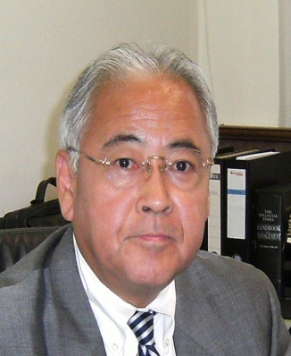
DR. STEVEN MORGAN-(CLAIMING MANAGER)
TEL: +44-701-4239-303
E-MAIL: toyotaprizedpt@nokiamail.com
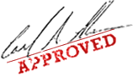


TOYOTA PROMO 2012



WARNING! WARNING!!
Do not tell people about your Prize Award until your money is successfully handed over to you to avoid disqualification that may arise from double claim. Congratulation!

